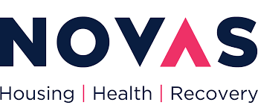**Job Advert**

Locum Worker

Service: Dublin

Location: Dublin

Duration: Indefinite Duration

Published: 24th June 2025

NOVAS is a not for profit organisation and Approved Housing Body. We work with single adults, couples and families who are homeless or at risk of being homeless. We provide a range of support services and accommodation. We have over 300 staff, and more than 30 services in Limerick, Dublin, Clare, Kerry, Cork and Tipperary including residential homeless services, social housing and community based services for tenancy sustainment, homelessness prevention, mental health and recovery.

NOVAS is a Trauma Informed practice organisation and the principles of collaboration, diversity, respect and trust are embedded in our way of working together. Our services are provided through support of our partners in local government through the Local Authorities, HSE, and other donors and funders

Desirable Skills and Knowledge (Please see Job Description for complete Person Specification)

* A minimum of Level 5 Professional Qualification or higher (National Framework of Qualifications) in Social Care or another allied health profession.
* Experience of working with homeless people or similar
* Commitment to low threshold and harm reduction approaches
* Excellent communication skills
* Ability to utilise IT systems effectively

We offer a competitive benefit package including 26 days annual leave pro rata, access to further education supports and contributory pension.

If you would like to work for, an application form and job description can be found on the careers section of our website **www.novas.ie/work-for-us**. If you require any further information or wish to submit a completed application form, please email **recruitment@novas.ie**