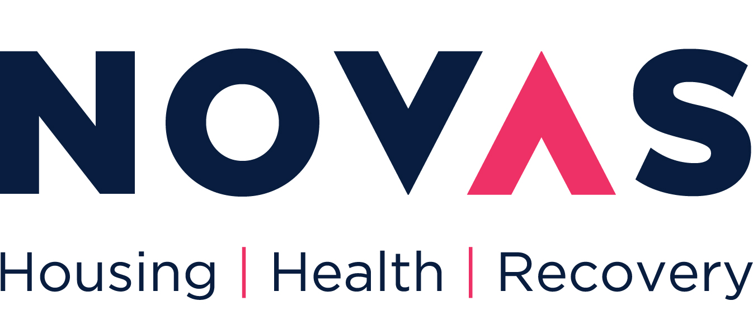

GOOD NEIGHBOUR AGREEMENT

**Introduction**

Novas believes that everyone has the right to live in their own home without undue disruption or disturbance from others.

As a tenant you are expected to keep to the terms of your Tenancy Agreement. You have a responsibility to ensure that you are not acting in a way that is likely to annoy or disturb your neighbours. In terms of your tenancy agreement you are responsible for the behaviour of your children, your pets and all visitors to your home.

To assist with the prevention of Anti-Social Behaviour, promote good relations and assist with the development of stable, sustainable communities Novas will encourage you to sign a “Good Neighbour Agreement”.

This agreement is a voluntary charter and aims to outline your responsibilities as a tenant and to inform you of the conduct expected of you as our tenant. Every tenant will be asked to sign this document. The purpose of the document is to obtain a commitment from you that will ensure that you, your family and visitors will contribute to a safe and welcoming neighbourhood by showing respect and tolerance to others. This is not a legally binding document. Any serious incidents will be dealt with under the terms of our tenancy agreement.

**Be a Good Neighbour!**

* Be aware that sound travels – do not make loud, persistent noise, particularly in the evening or early morning (examples of this would be playing loud music or using power tools).
* Be responsible for the behaviour of your children and ensure that they are not causing undue noise or nuisance to neighbours.
* Keep all pets under control at all times – dogs should be kept on a leash and not allowed to foul in common areas or on other peoples property.
* Be responsible for the behaviour of visitors to your homes (this includes your childrens visitors).
* Do not allow anyone visiting your home to cause vandalism in your home or surrounding areas.
* Report any acts of vandalism to Novas at your earliest convenience.
* Support initiatives within your neighbourhood.
* Treat all neighbours in a respectful manner.
* If you have a garden ensure it is maintained on a regular basis. Keep it clean and tidy.
* If you live in an apartment or housing with shared spaces, do your part to keep these common areas clean.
* If you have a balcony ensure it is kept clean and tidy. Do not store refuse or other items on it that may cause nuisance to your neighbours below.
* Ensure that you and your visitors park considerably and do not block driveways or take up neighbours parking spots.
* During times of crisis such as adverse weather conditions or pandemics such as Covid 19 check in on your neighbour, see if you can be of assistance to them. Adhere to visitor restrictions should they be in place.
* If your children wish to play outside on the street or common areas, please be mindful of the time, other peoples belongings and property. Remember roads are for cards and are a dangerous playground.

**Breaches of Conduct**

Everyone can play their part in making their home and the surrounding area a better place to live, by considering the impact their lifestyle may have on their neighbours and the environment. Being a good neighbour is about common sense, having consideration for other people and respect for different lifestyles and cultures.

Novas aim is to resolve neighbour disputes amicably. However, where this fails we will follow the due process under Anti-Social Behaviour and Noise Pollution and if the behaviour persists we will seek to gain possession of your home.

**Agreement**

I/We support the Good Neighbour Agreement and agree to abide by its principles

**Signed ……………………………………………………………………………………….**

**Joint Tenant ………………………………………………………………………………………..**

**Address ………………………………………………………………………………………..**

**………………………………………………………………………………………..**

**………………………………………………………………………………………..**

**Date ………………………………………………………………………………………..**